

**CSE302: Database Systems (Section 01)**

**[Summer 2021]**

**Group: 2**

**Project Report**

# Olympic 2020-Tokyo

https://apex.oracle.com/pls/apex/f?p=41650

**Submitted by:**

|  |  |  |
| --- | --- | --- |
| **Student ID** | **Student Name** | **Contribution Percentage** |
| 2019-1-60-023 | Md.Amir Abdal Sobhani | 33.34% |
| 2019-1-60-024 | Adri Saha | 33.33% |
| 2018-3-60-108 | Abid Hasan Rafe | 33.33% |

# Final version of the E-R Model of the Project

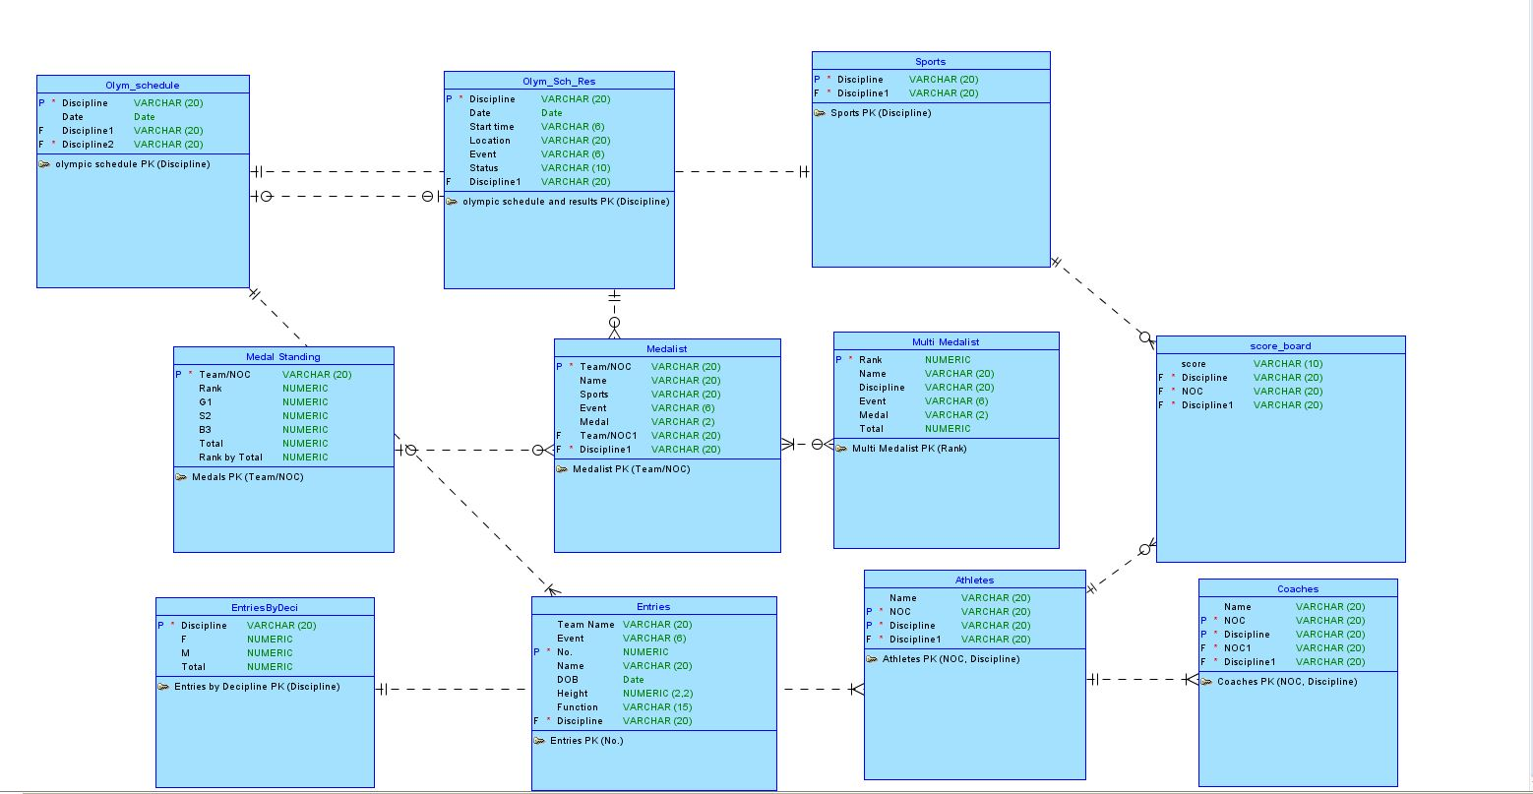

Figure: ER Model (Logical)

# Final Version of the Relational Data Model of the Project

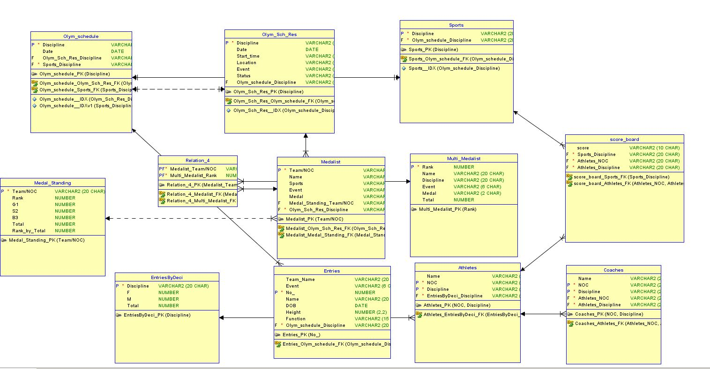

Figure: ER Model (Relational)

# Implementation Checklist

|  |  |
| --- | --- |
| Description | Remarks |
| Project ID | 41650 |
| Workspace Name | s2019160023 |
| Workspace Email | 2019-1-60-023@std.ewubd.edu |
| Workspace Password | sobhanifahim |
|  |  |
| Authentication Type | Custom |
| Username and Password to Login |  |
| write username like admin | write password like *admin123* |
| if you have multiple users, write all username and password correctly |  |
|  |  |
| USERNAME: admin | PASSWORD: admin123 |
| USERNAME: adri | PASSWORD: adri123 |
| USERNAME: rafe | PASSWORD: rafe123 |
|  |  |
| Uploaded and Displayed Images in Reports | yes |
| Implemented Page-wise Authorization | no |
|  |  |
| Number of Reports with Forms | 9 pages |
| Number of Master-detail Forms | 1 page |
| Number of Reports based on Queries, Aggregate Queries | 3 pages |
| Number of Parameterized Reports | 2 pages |
| Number of Graphs/Charts | 5 charts |
|  |  |
| Included any trigger/other feature which is not taught in class. If yes, please explain briefly. | Yes, we have included triggered at 2 pages.   * Olympic Schedule, * Olympic schedule & results   Also created feedback page where viewers can give opinion. |
| Write the most unique feature/functionality in your application or the page of your application which you are proud of. Explain briefly. | We applied html, CSS on 7 pages including home page, sports, videos etc. Also added background, logo & login page picture, home page, sports pages, news etc.  We inserted triggered on Olympic schedule data where entries can’t be taken if date is earlier than 21-July-2020 or late than 8-august-2020. As it is application for Olympic 2020. So that, we made this triggered. |

# Reports with Forms

|  |  |  |
| --- | --- | --- |
| Report Page Number and Name | Form Page Number and Name | Table |
| P7. Olympic Schedule | P8. Olympic Schedule Data | olym_schedule |
| P15. Olympic Schedule & Results | P16. Olympic Schedule & Results data | olym_sch_res |
| P26. Entries | P30. Entries data | entries |
| P20. Medal Standing | P21. Medal Standing Info | medal_standing |
| P23. Medalist | P23. Medalist Info | medalist |
| P39. Multi Medalist | P40. Multi Medalist Data | multi_medalist |
| P2. Athletes | P3. Athletes_data_entry | athletes |
| P4. Entries by discipline | P5. Entries by discipline | entriesbydeci |
| P10. Coaches | P17. Coaches_info | coaches |
| P13. 3X3 Basketball (schedule part) |  | |
| P14. Archery (schedule part) |
| P18. Athletics (schedule part) |
| P22. Badminton (schedule part) |

Put screenshots of each of your reports and forms used for data input mentioning the name of the table in your database schema. Number your figures like 4.1, 4.2 and so on.

* 1. **Olympic Schedule Report**

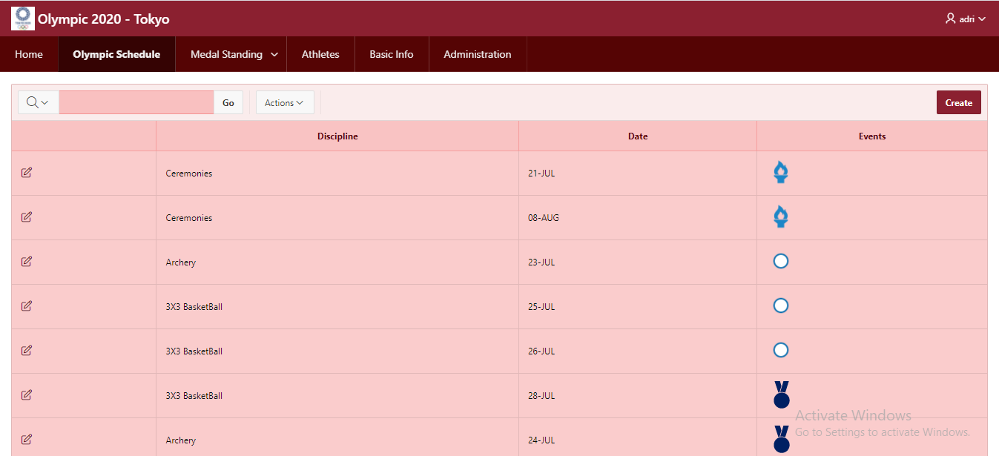

* 1. **Form: Olympic Schedule Data**

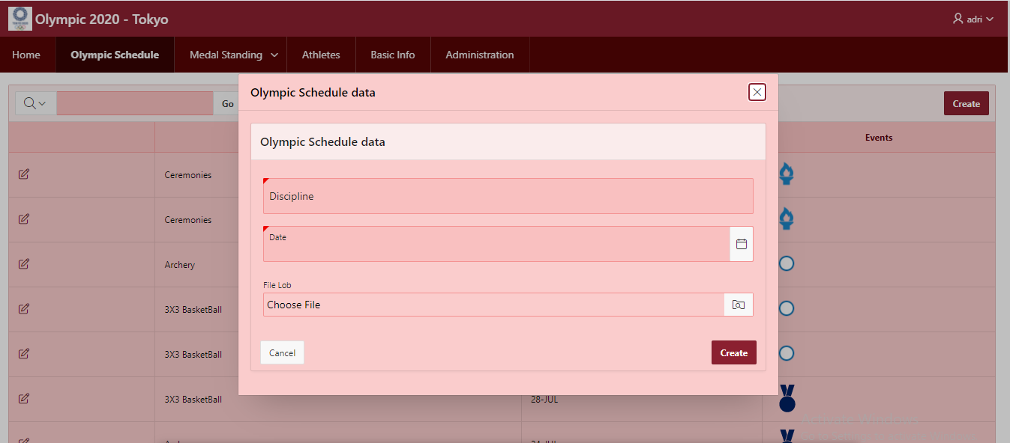

* 1. **Olympic Schedule & Results**

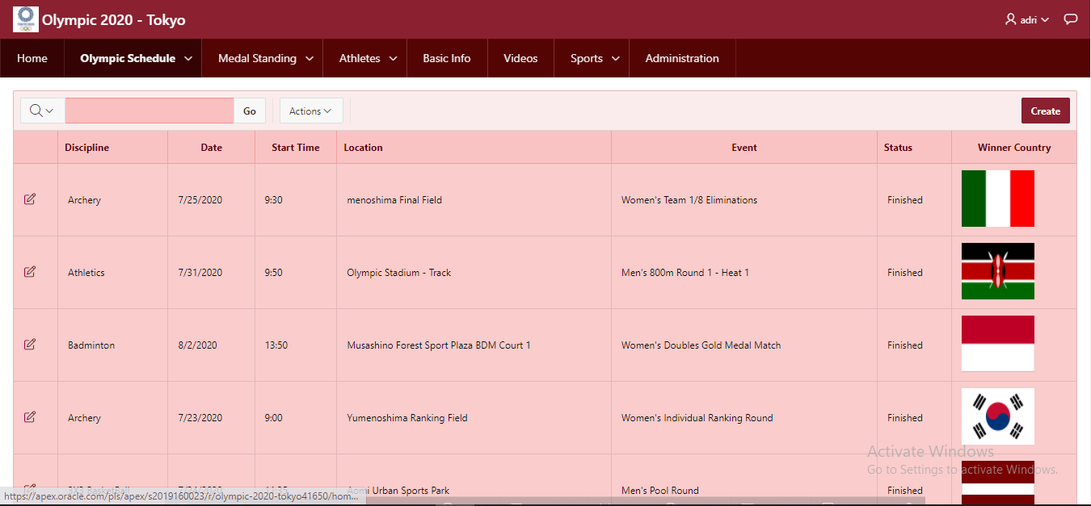

* 1. **Olympic Schedule & Results data**

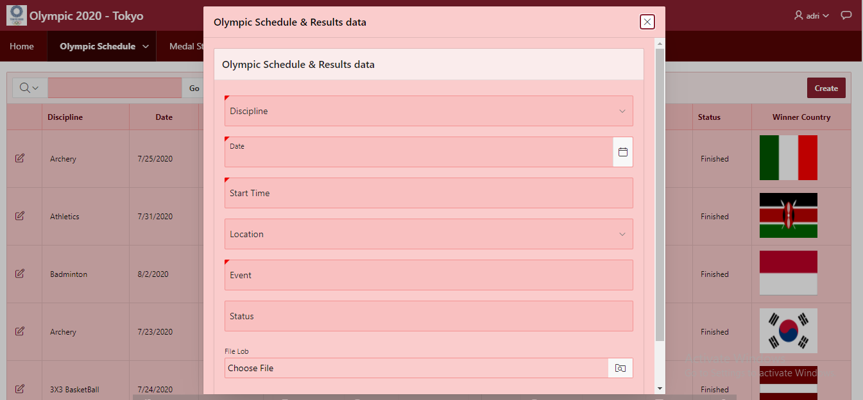

* 1. **Entries**

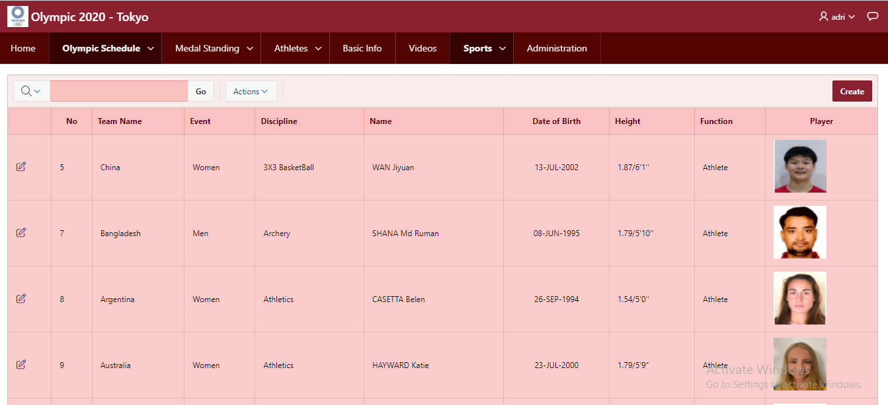

* 1. **Entries data**

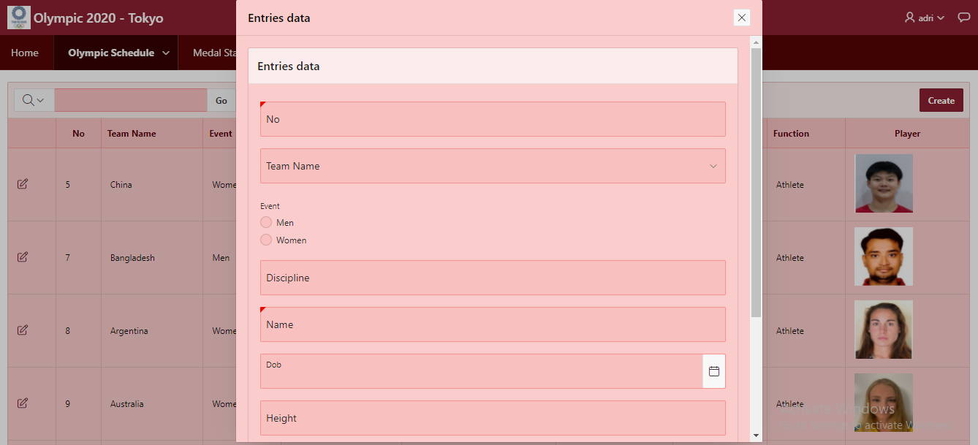

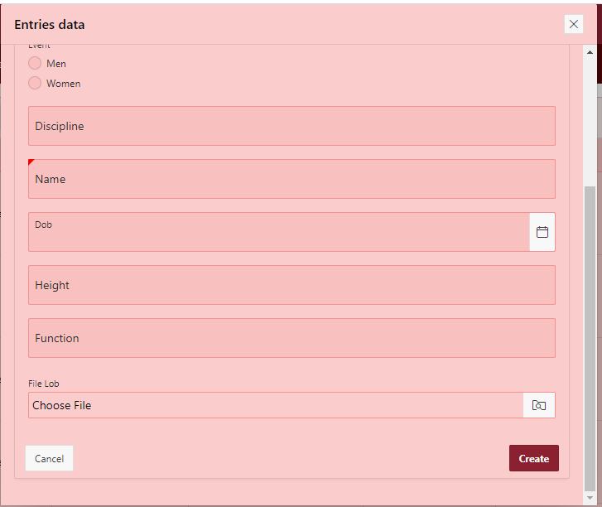

* 1. **Medal Standing Report**

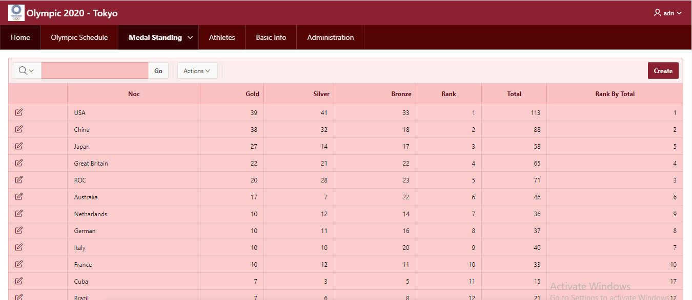

* 1. **Medal Standing Form:**

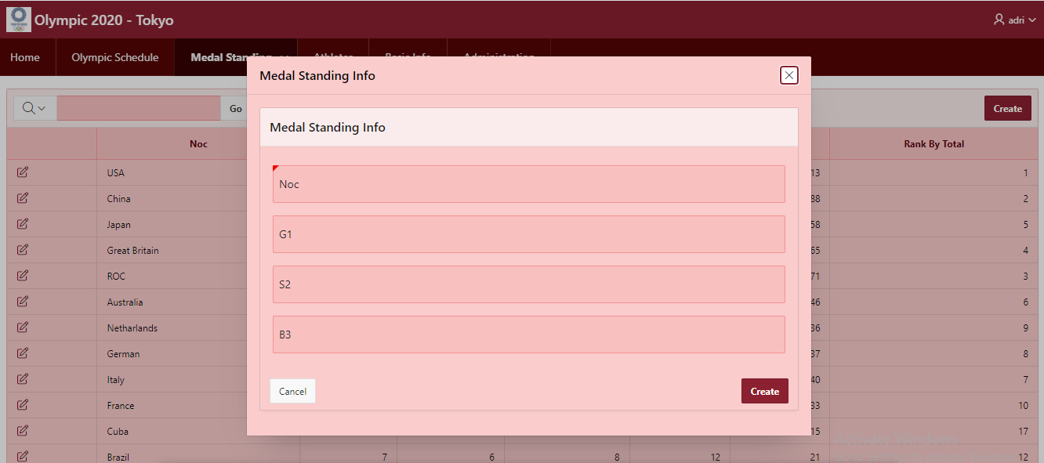

* 1. **Medalist Report:**

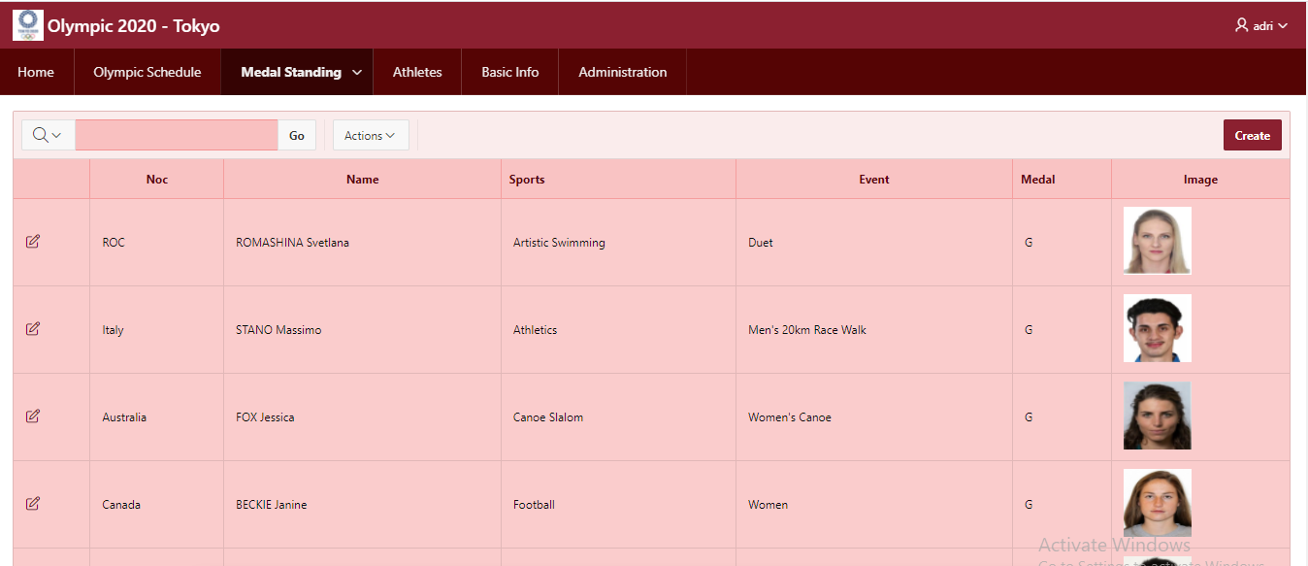

* 1. **Medalist Info Form:**

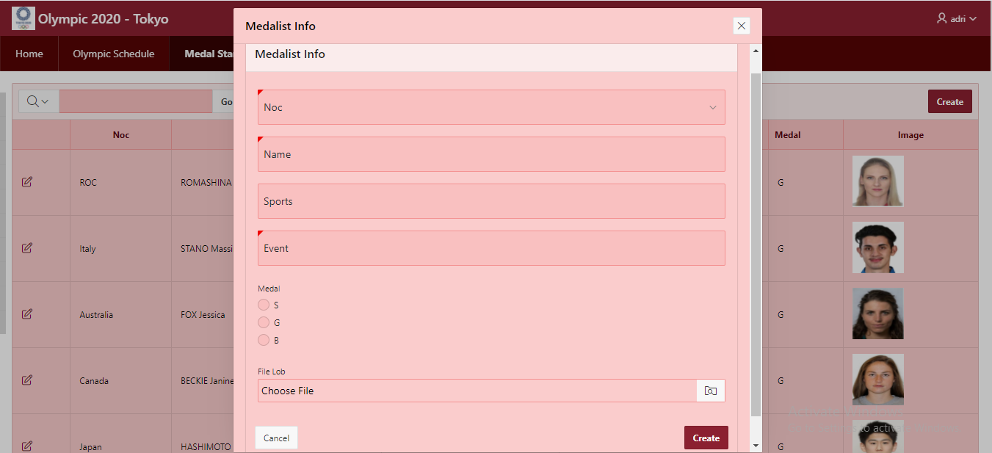

* 1. **Multi Medalist**

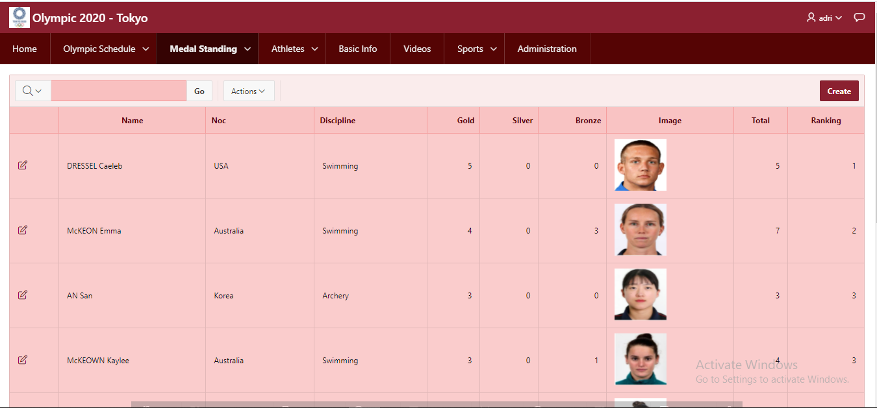

* 1. **Multi Medalist Data**

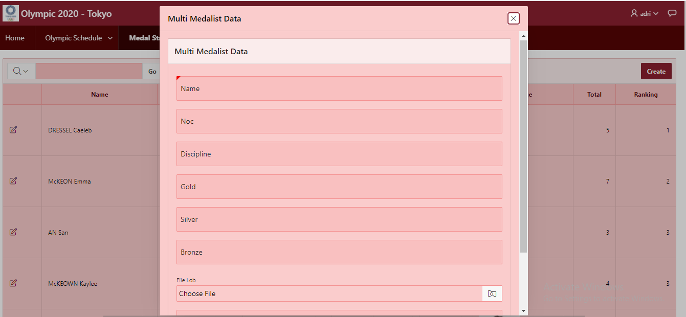

* 1. **Athletes**

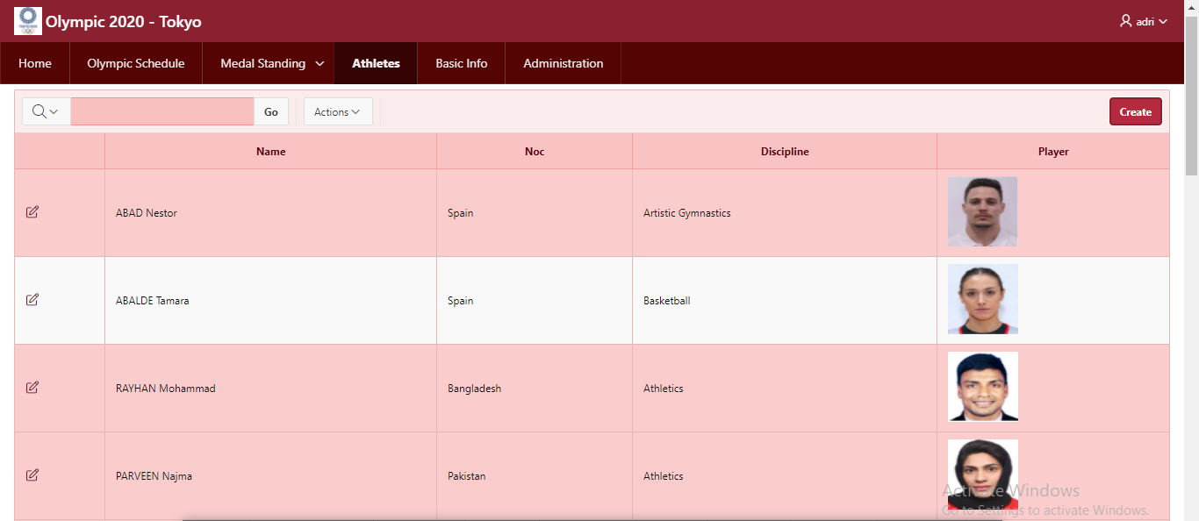

* 1. **Athlets_data_entry**

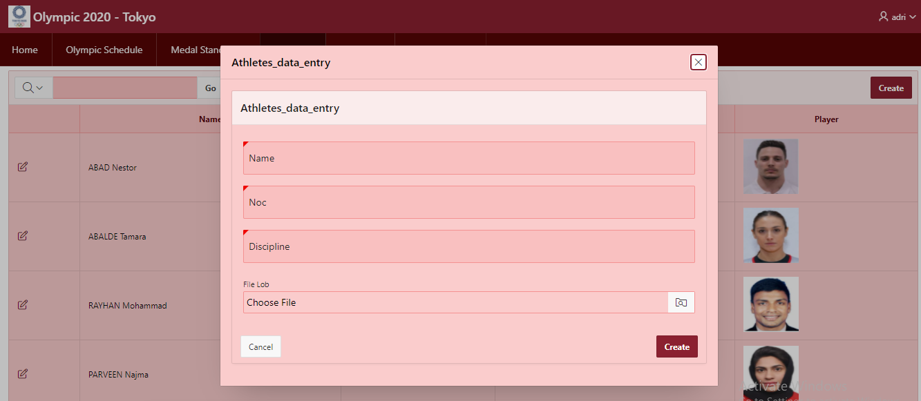

* 1. **Entries by discipline**

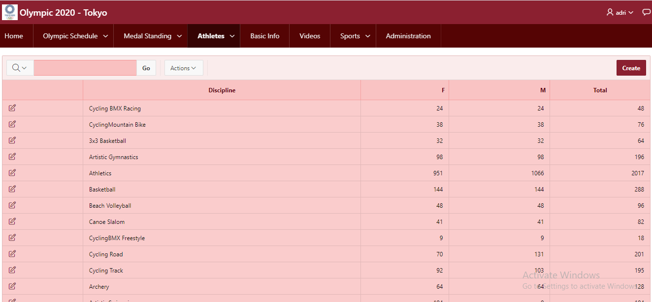

* 1. **Entries by discipline Data**

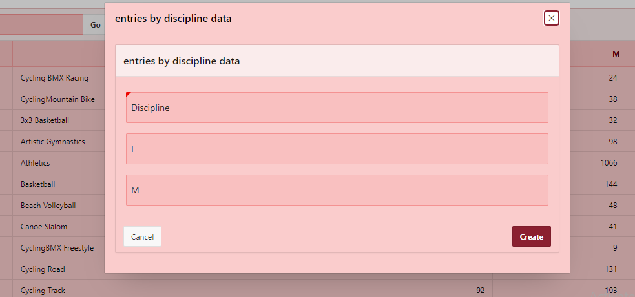

* 1. **Coaches**

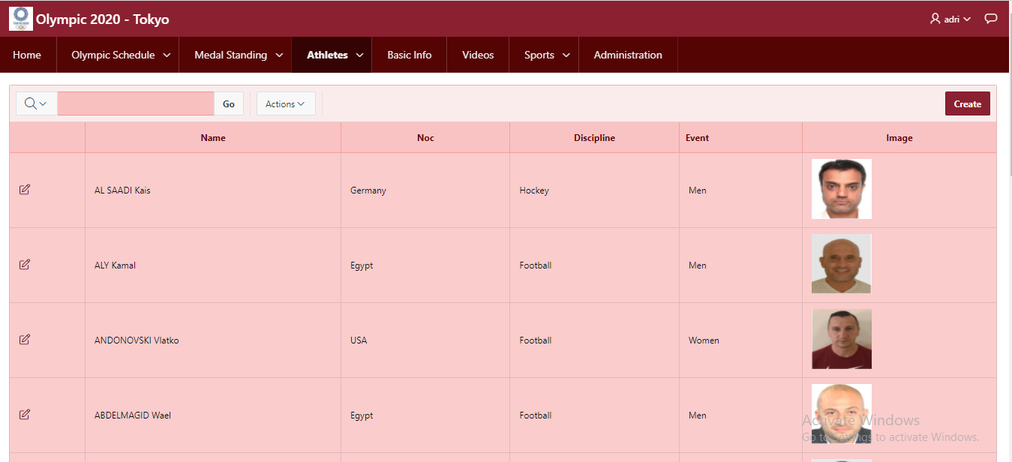

* 1. **Coaches_info**

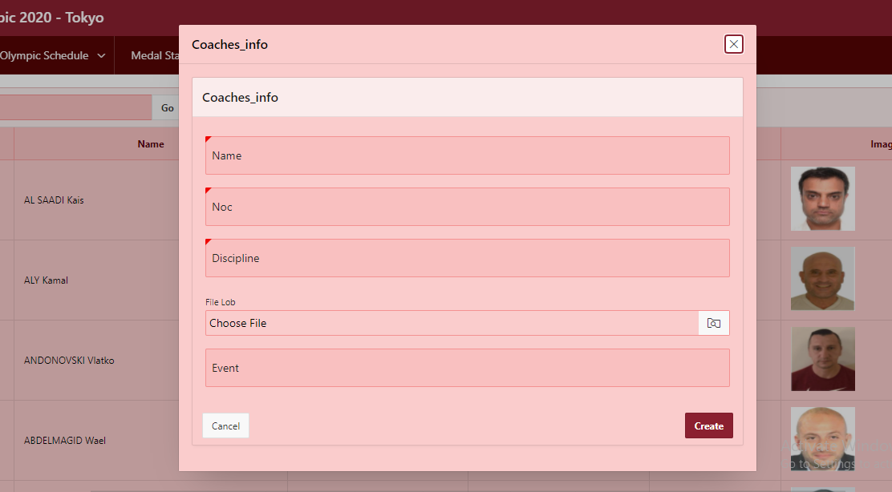

**Then,** we also created some report pages for sports where the sports related news, photos, information, schedule are given.

These are:

* 1. 3*3 Basketball schedule(P-13)

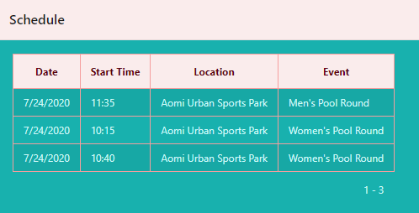

* 1. Archery schedule (P-14)

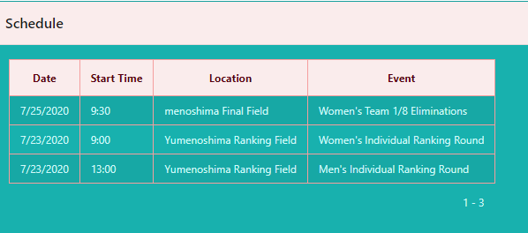

* 1. Athletics schedule (P-18)

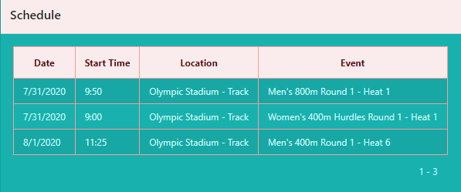

* 1. Badminton schedule (P-22)

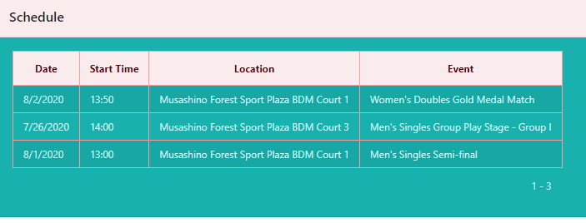

# **Master-Detail Form**

|  |  |  |
| --- | --- | --- |
| Page Number and Name | Master Table (Parent) | Detail Table (Child) |
| P27: Medal-Medalist Info | medal_standing | medal |

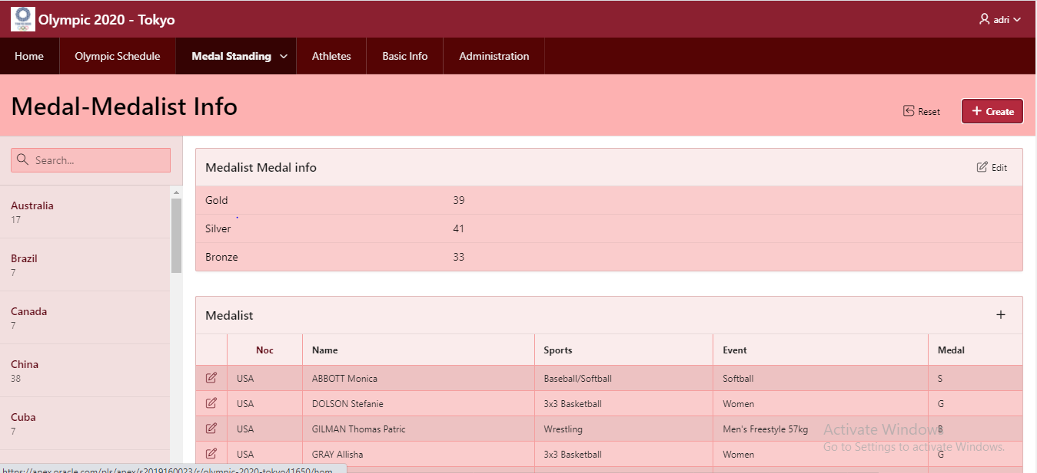

Figure 5.1: NOC-wise medal Information

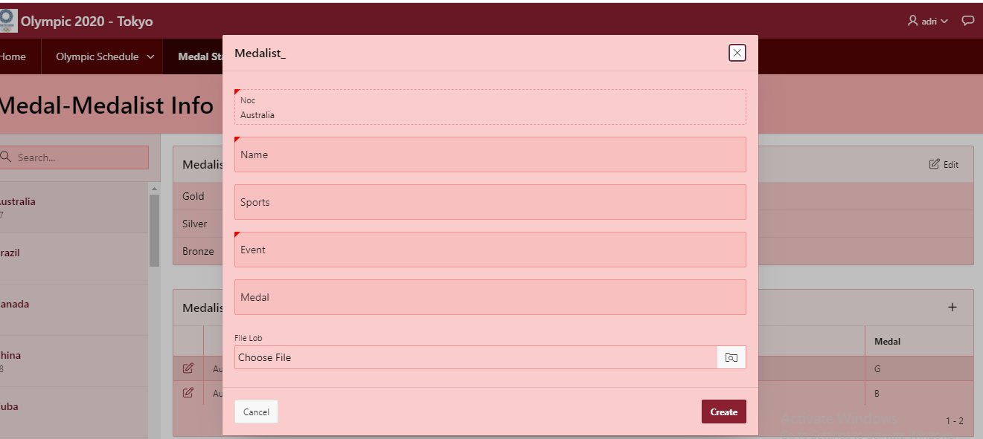

Figure 5.2: Also can add entries from master table

# Reports based on Multi-Table and Aggregate Queries

|  |  |  |
| --- | --- | --- |
| Page Number and Name | Query Type | Report description |
| write your report page number and name here | Multi-table/Aggregate | write the description of the report in a simple sentence such as this report shows the total number of instructors per department. |
| P39. Multi Medalist | Multi Table | By this multi table entering someone’s name we can easily find out which medals he/she got on which event. |
| P4. Entries by discipline | Aggregate Queries | By this query we can find out the total number of individual female & male entries. Also, total male & female entries. |
| P20. Medal Standing | Aggregate Queries | By this query we can find out the total medals, total rank by gold medal as well total rank by all models |

# Multi- table from Multi Medalist

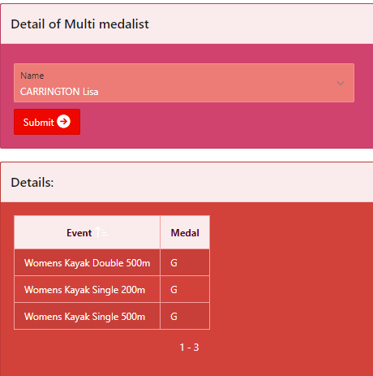

* 1. Aggregate queries from Entries by discipline

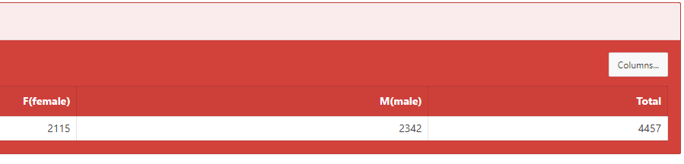

1. Aggeregate queries from Medal Standing

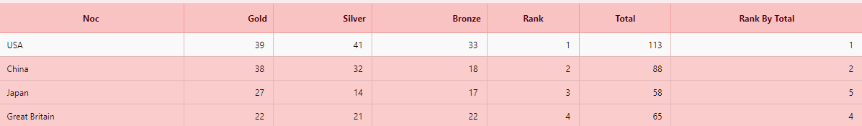

# Parameterized Reports

|  |  |  |
| --- | --- | --- |
| Page Number and Name | Given Input | Report description |
| P36. Search for player | Discipline, Event | It shows the players information of a particular discipline & event |
| P10. Coaches | NOC, Sport | It shows the coaches names for a particular NOC & Sport |

* 1. **Search for player**

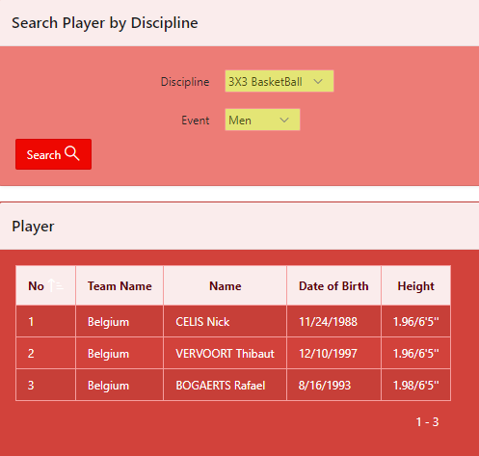

* 1. **Country wise Coaches**

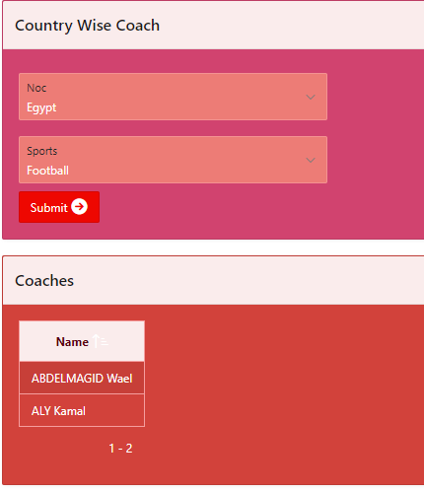

# Charts

|  |  |
| --- | --- |
| Page Number and Name | Chart description |
| P31: Basic Info | The bar chart shows country wise winning gold medals from ‘medal standing’ table. |
| The bar chart shows country wise winning silver medals from ‘medal standing’ table. |
| The bar chart shows country wise winning bronze medals from ‘medal standing’ table. |
| The pie chart shows discipline wise male participation from ‘entriesbydeci’ table. |
| The pie chart shows discipline wise female participation ‘entriesbydeci’ table. |

**Basic Info (Chart Report): Page 31**

* 1. Gold medal wise country

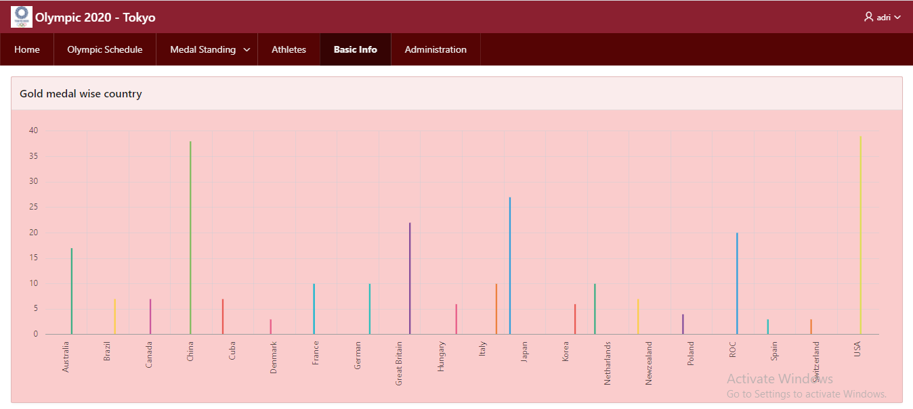

* 1. **Silver medal wise country**

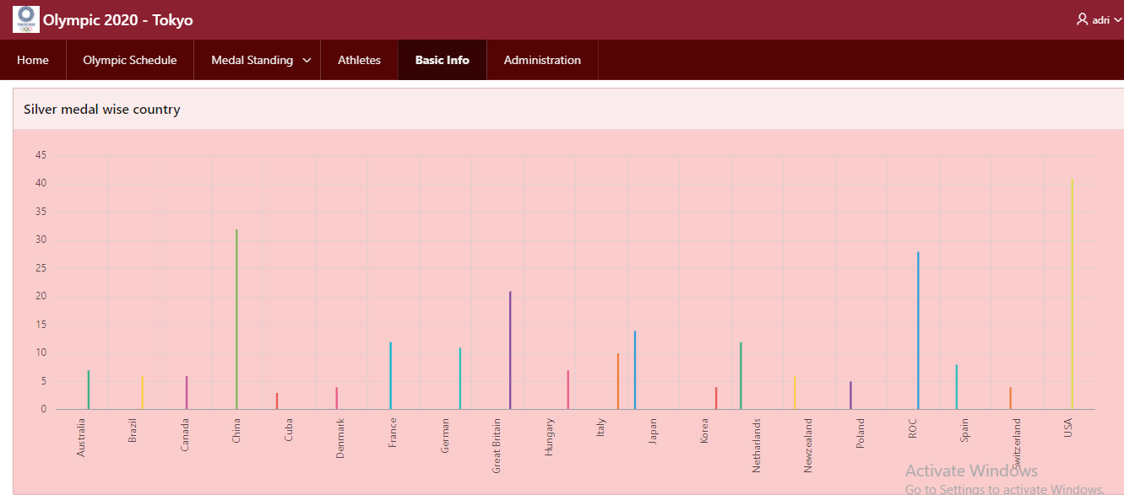

* 1. **Bronze medal wise country**

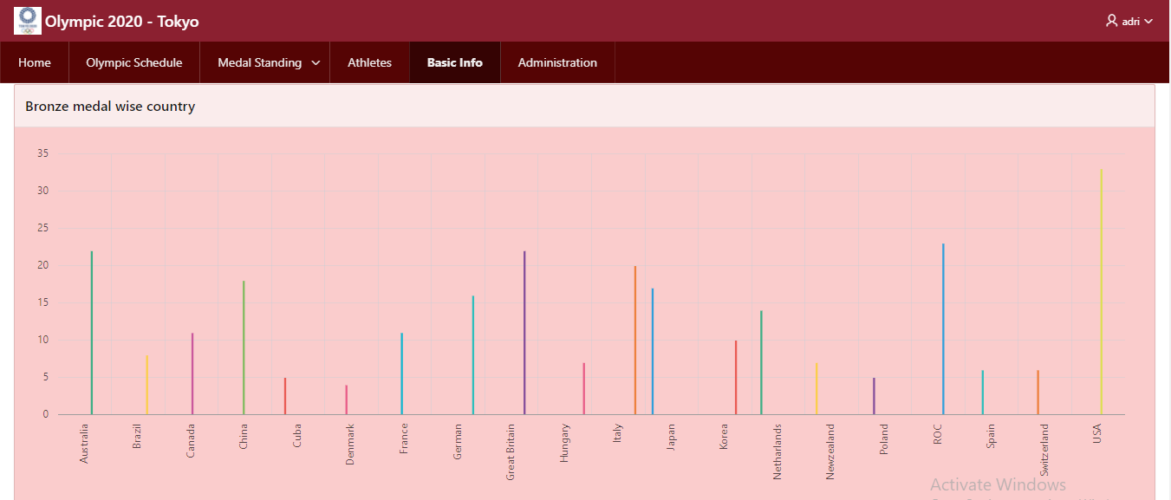

* 1. **Discipline wise male participation**

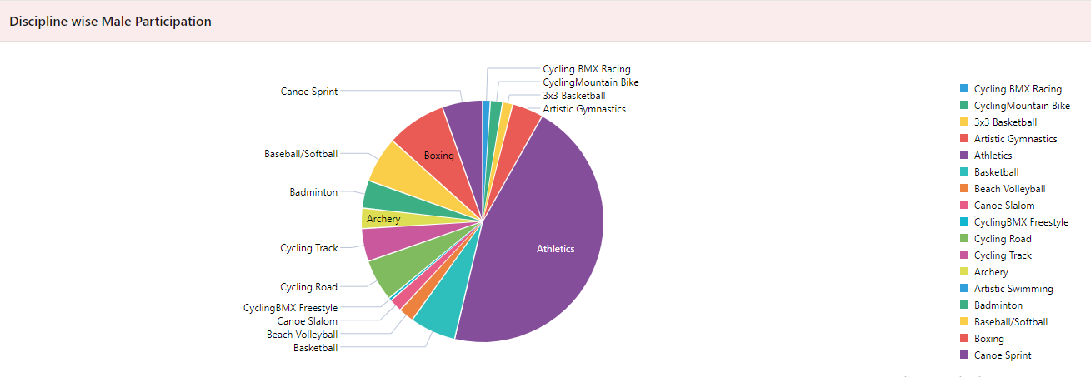

* 1. **Discipline wise female participation**

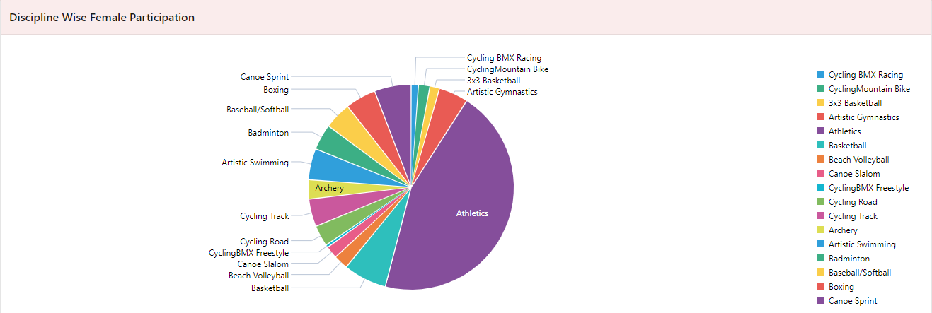

# Some extra functions in our application:

# We have also created feedback page, some blank pages to add Olympic news, photos, featured videos, logo, background images by using html, CSS. There are some screenshots are in given below:

Video page (P-11):

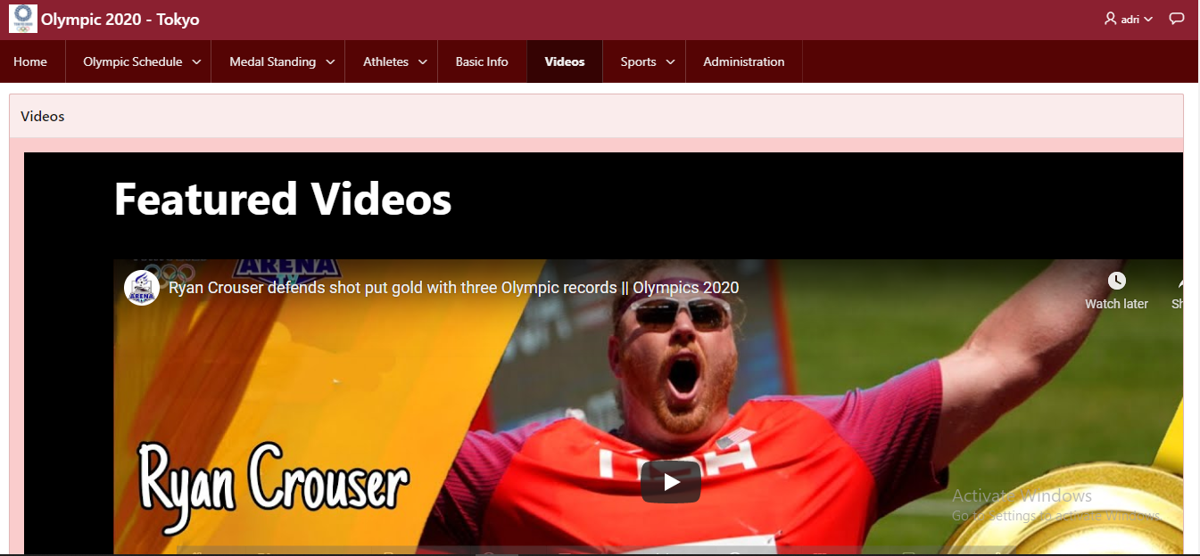

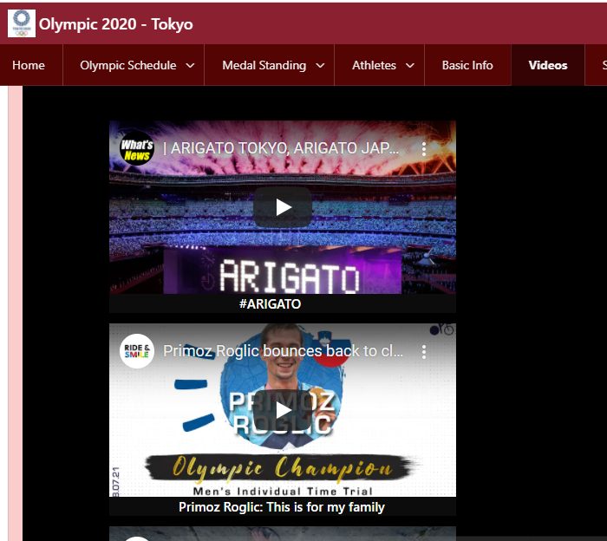

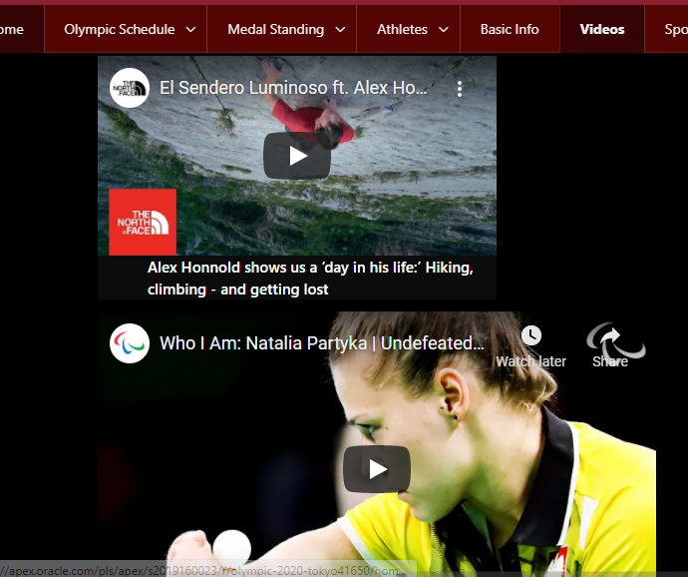

Sport Page:

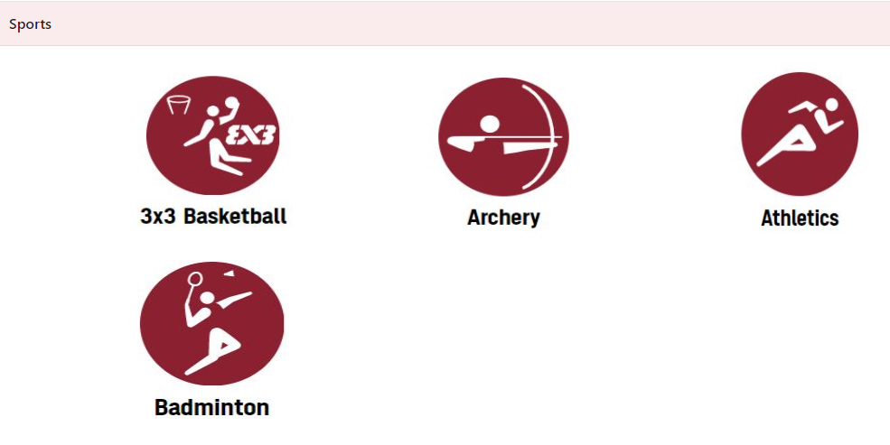

By clicking on that,

**3x3 Basketball: (P13)**

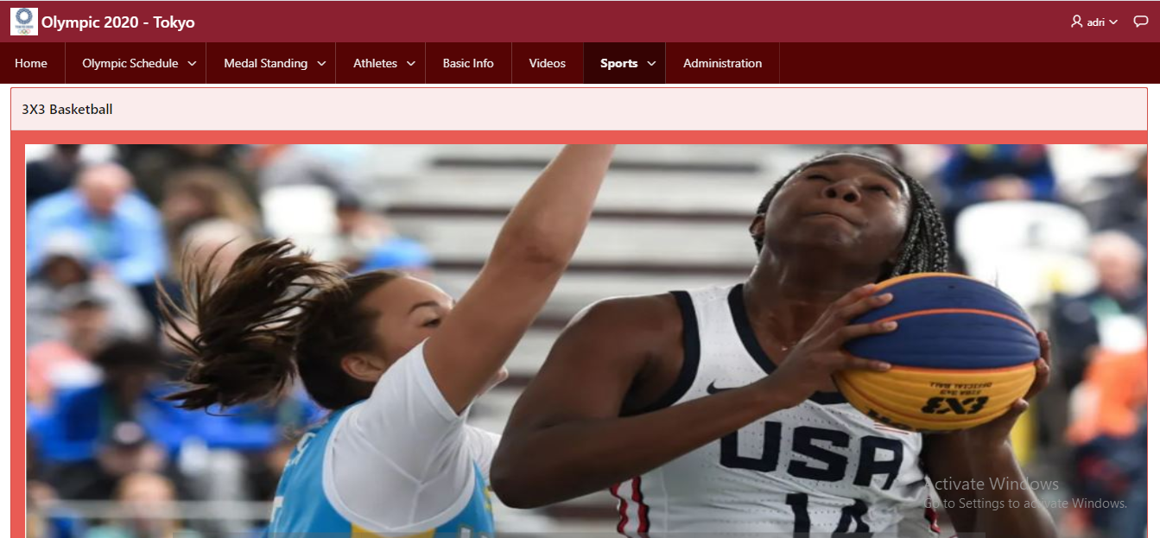

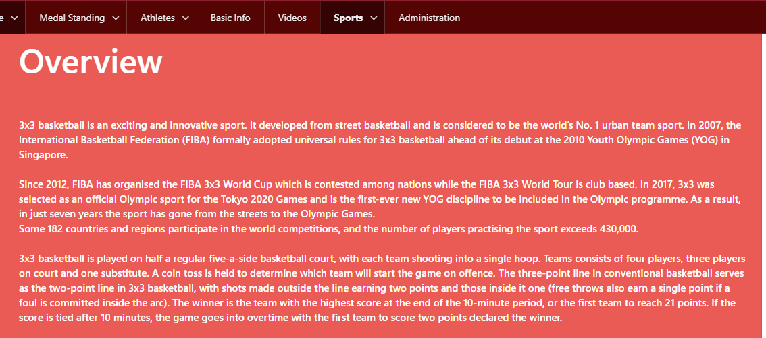

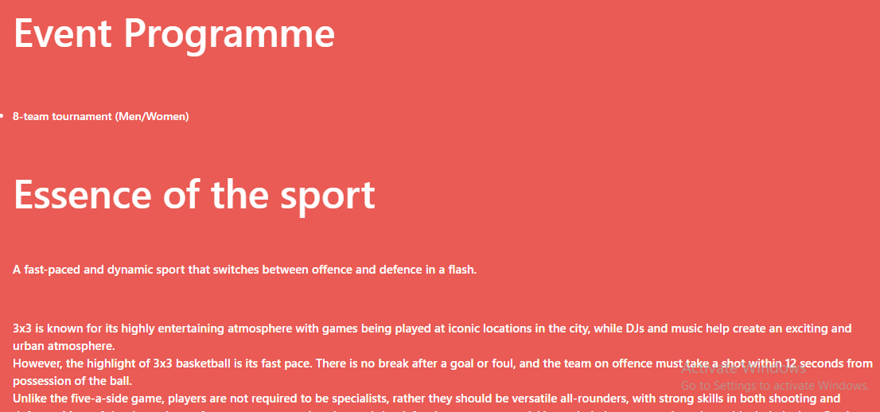

**Archery (P14):**

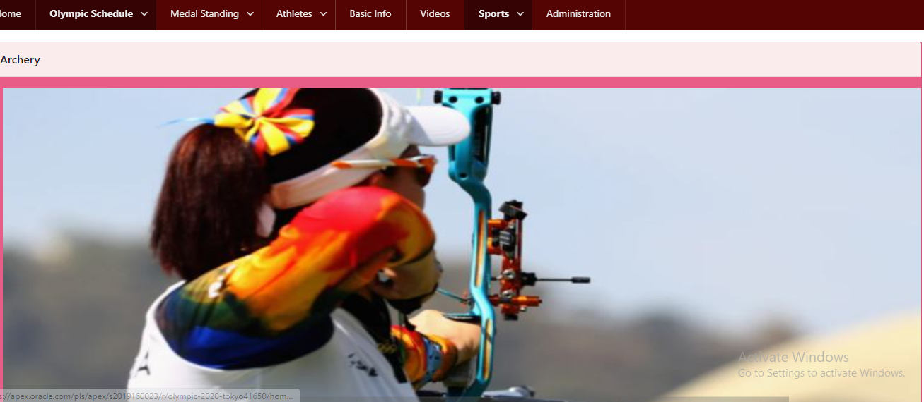

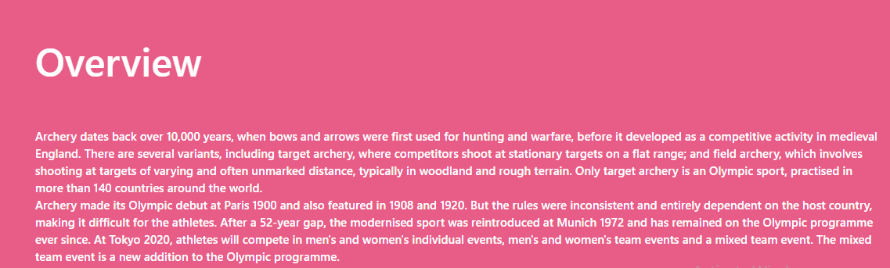

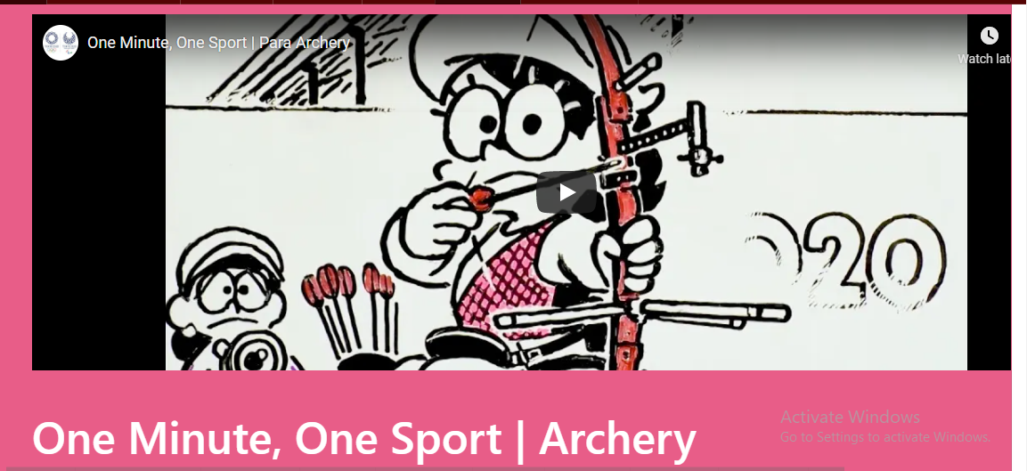

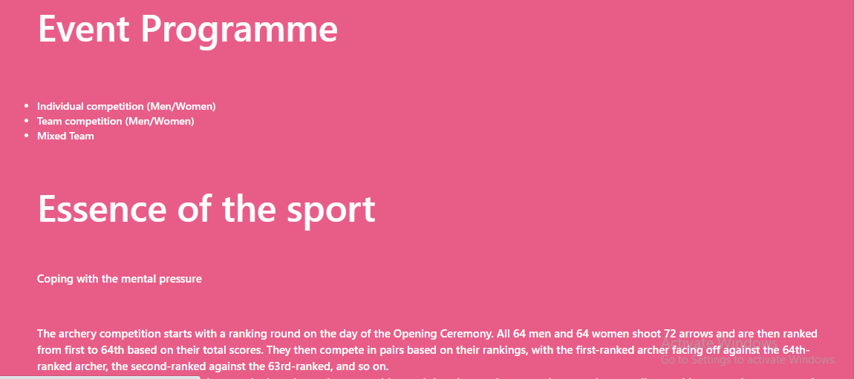

**Athletics(P-18):**

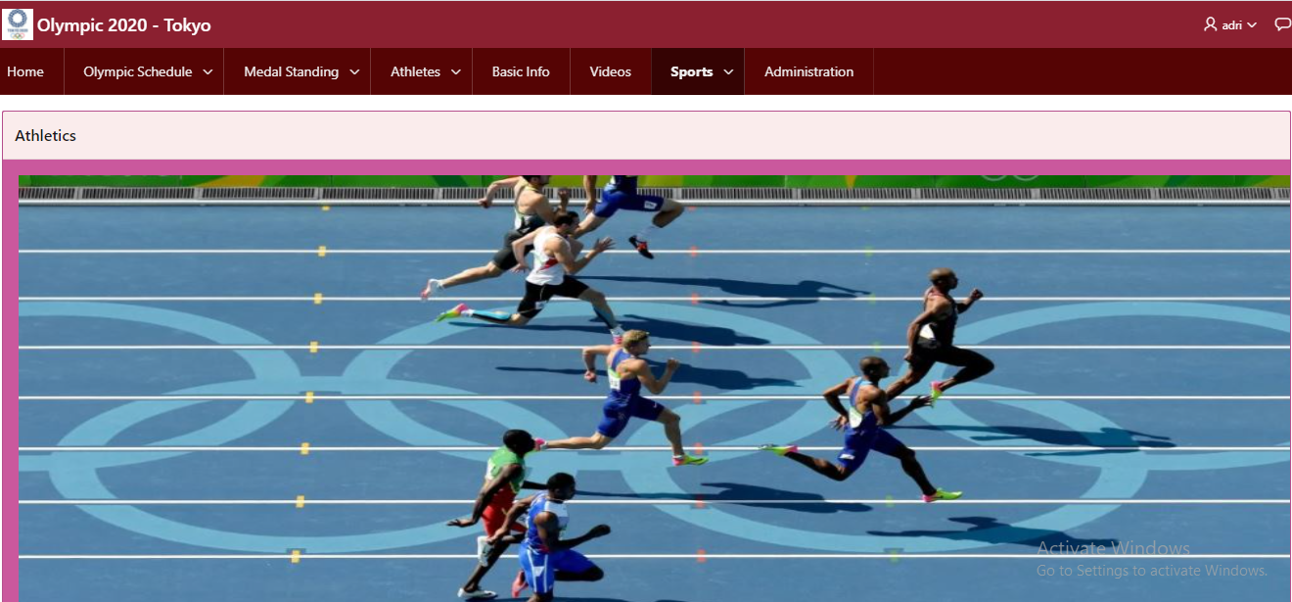

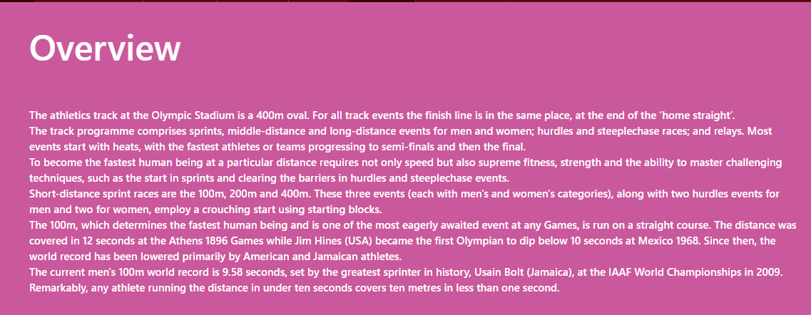

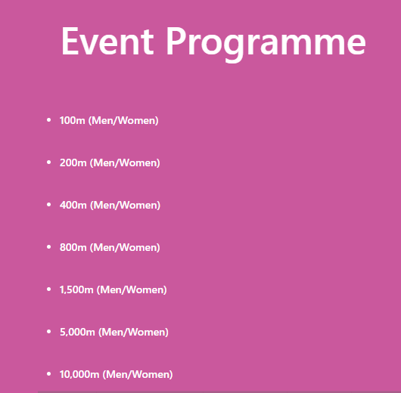

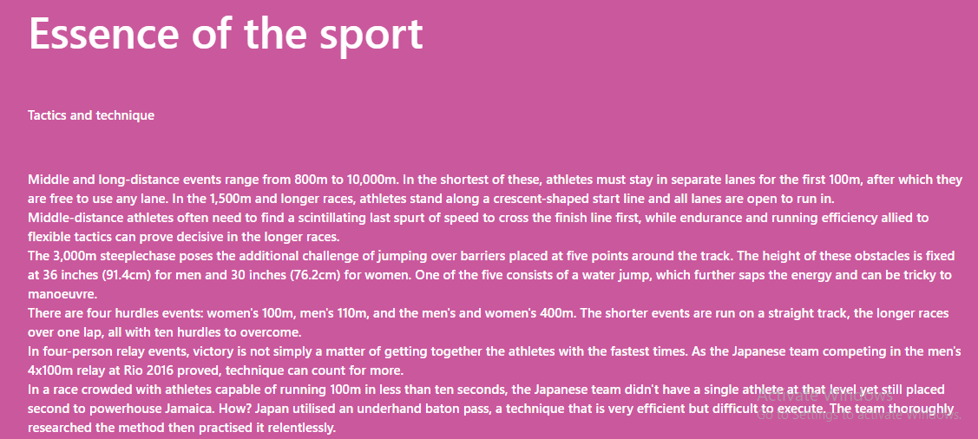

**Badminton(P-22):**

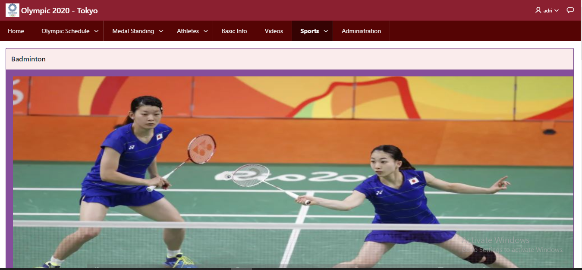

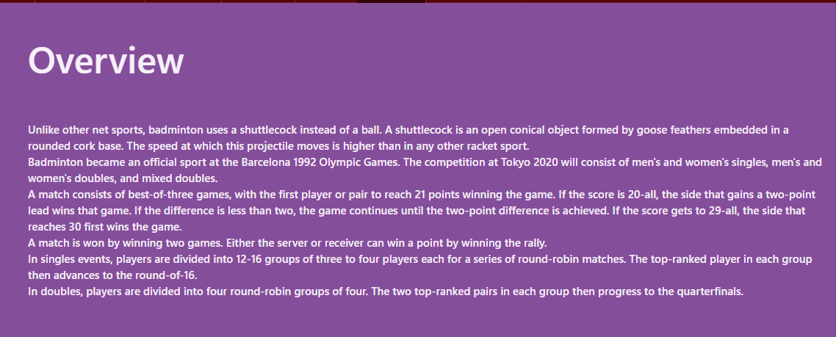

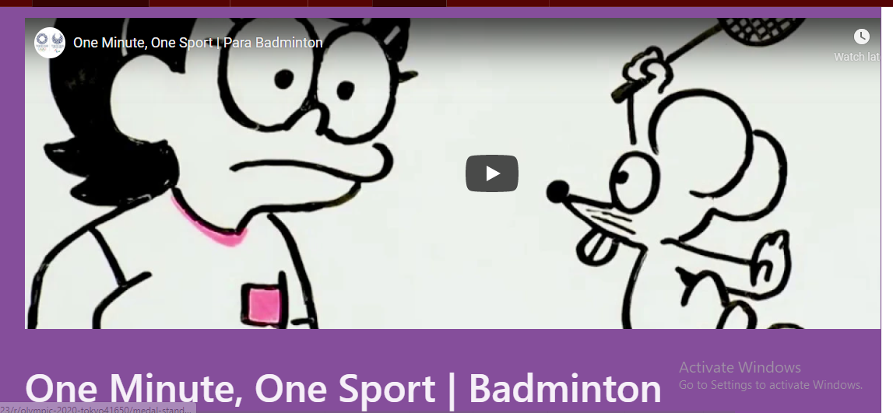

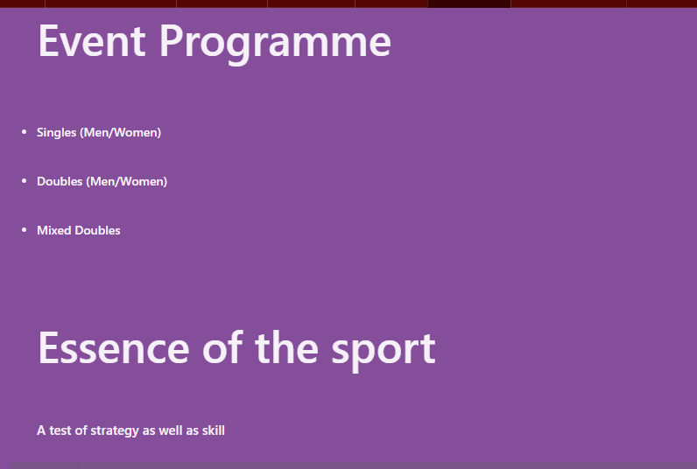

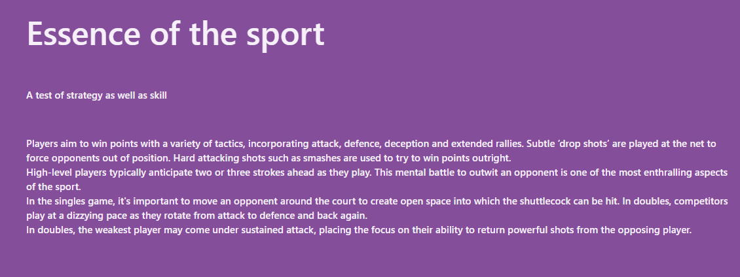

**Home Page (Page 1):**

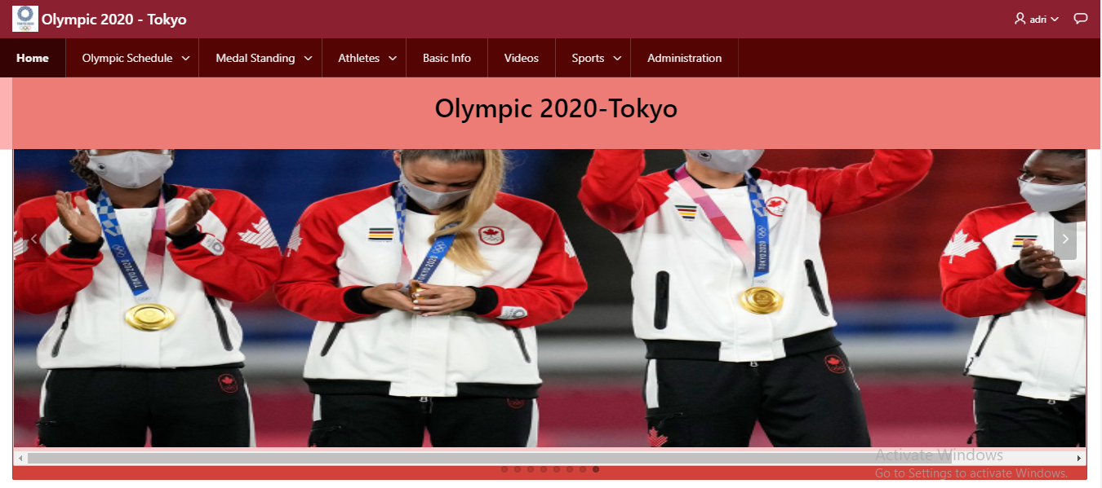

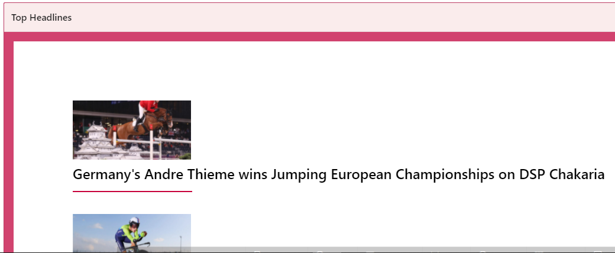

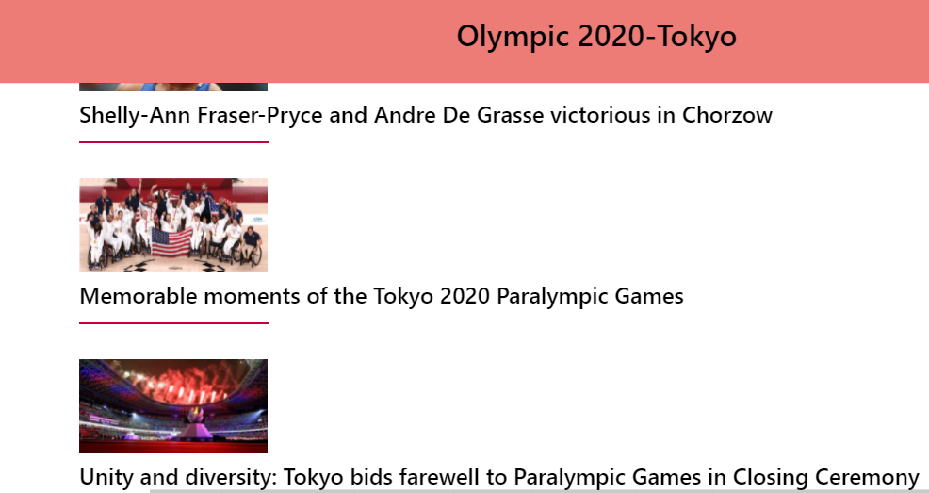

**Feedback page:**

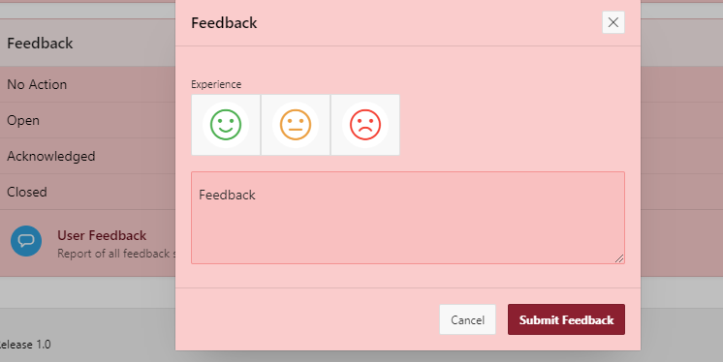

**Login page:**

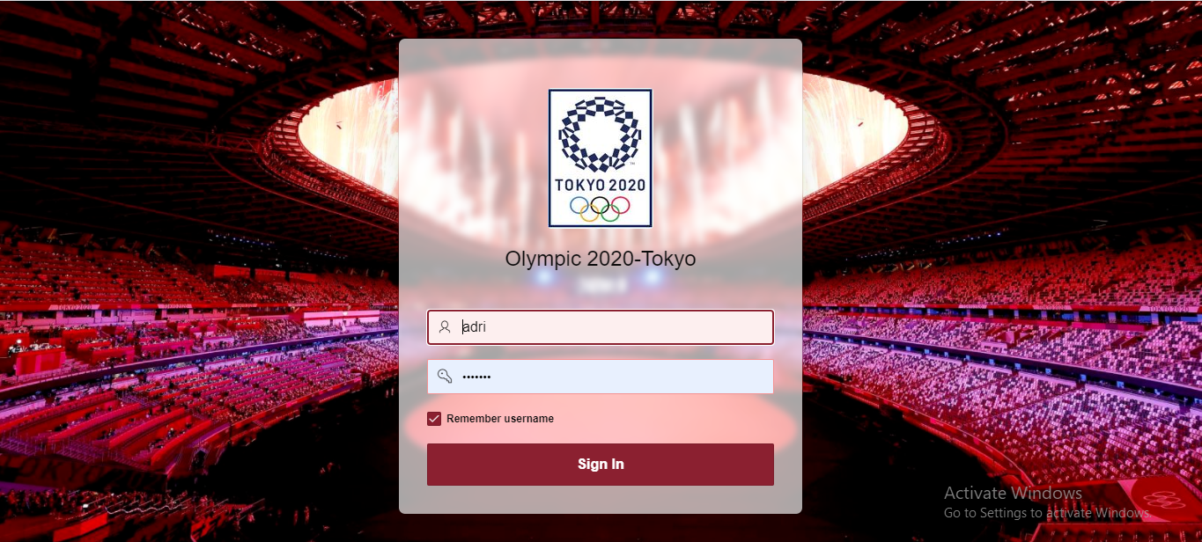

# Authorization and User Role Assignment

**User Role Assignment**

|  |  |  |  |
| --- | --- | --- | --- |
| Username | Password | Role | User Activated |
| admin | admin123 | Administrator | 1 |
| adri | adri123 | Administrator | 1 |
| rafe | rafe123 | Administrator | 1 |

.

# Concluding Remarks

First, we want to **THANK YOU** sir for giving us this great opportunity of doing this wonderful project with **ORACLE APEX**. By help of your guidance and some YouTube videos we able to implement this website. This project has increased our knowledge on making websites & made us more confident to become a future developer. We enjoyed a lot by making this webpage. We have learned to how to use sql, aggregate queries to make a proper website. By doing this project, we also faced some troubles. As an example, we were not able to be figuring out how to use triggers on this page as there is no one to one relation. That’s why we created a trigger where entries can’t be taken if date is earlier than 21-July-2020 or late than 8-august-2020. There was also challenging to add videos on websites. But after some research, we also add featured videos by help of html, CSS. So, despite everything we finally able to complete our project. We are very grateful to you to give us this opportunity to increase our knowledge and creativity on building websites.